**Helmet Detection using Image Processing**

**Shreya1, Rakshitha1, Vaishali1, Shreya1, Shrinivasa2**

**1** U.G. Student, Dept. of CSE, Shri Madhwa Vadiraja Institute of Technology and Management

Vishwothama Nagar, Bantakal

**2** Assistant Professor (Senior), Dept. of CSE, Shri Madhwa Vadiraja Institute of Technology and Management

Vishwothama Nagar, Bantakal

***Abstract*—*As the time passes new concepts come into existence and replace the old methods. Usage of computers, making machines to work are common nowadays. Machine Learning, Image processing are the trending subjects in this era. All the new work is based on these concepts. Even this paper uses the concept of Machine Learning, Image processing and Computer Vision to detect the presence of a helmet while a rider is riding. Haar features are used to detect the helmet and cascade classifier is used to give a positive or negative result based on whether the helmet is present or not. This project further gives warning to the rider if the result is negative, so that the rider wears the helmet and has a safe ride. If this is ignored after a few more warnings then, the raspberry pi is connected by the relay switch and the DC motor the two wheeler is stopped accordingly.***

**Keywords—Machine Learning, Image Processing, Raspberry pi.**

1. INTRODUCTION

Transportation is necessary in this modern world. People travel every day from one place to another for hours for work purposes, family purposes etc., when the distance is not too far individuals will prefer two wheelers over other modes of transportation. Government has issued many rules for the safety of us humans, the traffic police make sure that these rules are followed but it is not only their job, a person has to contribute for his/her safety equally as well. One of the ways to ensure the safety of riders is wearing a helmet. Sometimes people wear helmets only to escape from the vicinity of the traffic guards and they unfollow the rule when there is no one to monitor them. This always leads to threat to their lives.

So what is the solution for this problem? It is certain that we cannot solve this problem fully but we can maximize the number of riders wearing helmets. There are many helmet applications introduced now a days with sensors for detection of alcohol and drowsiness, to check whether helmet has been wore using pressure sensors and the other way of detecting the presence of helmet is using image processing, machine learning techniques collectively can also be called and object detection which is a  part of computer vision. More about these topics will be discussed in the coming chapters.

1. BACKGROUND AND RELATED WORKS

An image is a two-dimensional quantity. It can be represented by a function *f(x, y)* the terms *x* and *y* represents the position of the image intensity and the function *f* represents the value at that position. An image which has finite and discrete value of intensity is called a digital image. The elements which are present in the digital image are considered as pixels. Digital image processing [1] is a technique where a digital image is processed by a computer.

Images can be represented in various forms but to process an image in a computer it has to be compatible with the computer language hence 0’s and 1’s are used to represent the pixel values in the image this type of image is called a binary image. An image which has only black and white colors and their variants is called a gray-scale image, if an image comprises red, green, blue values (RGB) then it is a colored image.

Object Detection and Object Recognition **i**n very simple words can be said as detecting the object (e.g., detecting a dog in a given picture). Object recognition is a subdivision of Computer Vision. The extended version of object recognition is related to image processing where in the description of the recognized object should be given. So in standard format Object Recognition can be said as a technology related to Image Processing and Computer Vision.

Machine learning is concerned with learning computer programs and input are automatically experienced. The training data and testing data can be divided from the input. The training data is further divided as positive and negative samples. Using these samples the classifier is trained and later tested for the detection of the object.

In [2] Paul Viola et.al provided a different framework for robust and extremely rapid object detection. The first contribution is integral image. Second contribution is using AdaBoost selecting important features. Third contribution is a method for cascade structure which increases the speed of the detector. Two rectangular features, three rectangular features, four rectangular features are the three basis feather of Haar     basis function. The cascade algorithm radically reduces the computational time. This is the main algorithm we are using in this paper.

In [3] R. Silva et.al used a hybrid descriptor combining Circular    Hough Transform (HT), Local Binary Pattern (LBP) and Histograms of Oriented Gradients (HOG) to describe the feature of the object and then it was subjected to three different types of classifier: Naïve Bayes, Random Forest, Support vector Machine.

In [4] Rattapoom Waranusas et.al proposed a system which first identifies the moving object, Using the mixture model algorithm and background subtraction the object detection can be done and then the images are binarized by marking white for the moving parts and black for the stationary. The object that has been identified can be then classified as a motorcycle or any other object using KNN classifier. From a motorcycle region the head of the rider and the person behind the rider is counted and extracted. In the last part classification is made whether a rider is wearing a helmet or not wearing the helmet.

In [5] to improve the speed and accuracy during helmet detection YOLOv3 (You Only Look Once Version 3) has been used. The input to the YOLOv3 model is annotated images. If the rider doesn’t wear the helmet the license plate can be extracted. Extracted license plate if given to Optical Character Recognition (OCR) model, the model will output the predicted license plate number along with the confidence value.

In [6] Ashwin Arunmozhi et.al made a comparison between Histogram of gradient, Local binary pattern and Haar like feature for vehicle detection. KITTI dataset, udacity dataset and cascade classification detector were used for this purpose. The result of their comparison yielded that LBP feature extraction performs better than the other two. A new algorithm was proposed which was the combination of the three feature vectors mentioned above.

In [7] Priya Samyuktha M et.al used Haar cascade algorithm in considered as an open source computer vision to detect and recognize objects the result of which would be given as voice input to the visually impaired. For detecting the object image processing was used, and the processed image was next sent to Haar algorithm for further processing. The Raspberry pi 2 model was the mini processor in this case. Once when the objects detected matched the required features the description of the object is sent as voice output to the user through earphones, thus making the visually blind to detect the object easily.

In [8] Keelsons Aires et.al used combinations of six classifiers: support vector machine, radial basis function network, random forest, multi-layer perceptron, K nearest neighbors, naive Bayes and seven feature vector wavelet transform(WT), local binary pattern(LBP), histogram of oriented gradients(HOG), WT+LBP, LBP+HOG, HOG+WT, LBP+WT+HOG for helmet detection of motorcyclists. It was found that the HOG descriptor and multi-layer perceptron classifier put together gave the best result out of the 42 combinations. However, the used descriptor returned a large number of features which made the    classification difficult.

1. SYSTEM HARDWARE  DESIGN

Haar cascade classifier is used as feature descriptor [2], the Haar features has three basic features: two-rectangle feature, three-rectangle feature and four-rectangle feature shown in the below figure (Figure 1). The value is obtained in all the cases by first calculating the sum of intensities in different regions separately and finding  the difference between them.

Cascade classifier is a series of weak classifiers, the image is passed through each stage where it is marked as positive or negative depending on the presence of the object, If it is positive it is moved to the next stage, else discarded. If an object is found at the last stage then it is marked as an object detected. Else it is a negative image.

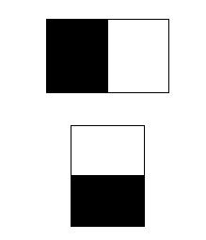

Figure 1: Two-rectangle Haar Feature.

The Raspberry Pi board is considered as the central module of the whole embedded image capturing and processing system as given in Figure 1. Mainly it includes: main processing chip unit, memory, power supply HDMI Out i.e., VGA display, Ethernet port, and USB ports.

1. Raspberry pi

Raspberry Pi Foundation developed  the series of single board computers. The main aim of this foundation was to provide education and easier access to computing education. The original device was launched in the year 2012, later several versions have been released as per the changes in the technology.

The Raspberry Pi 2 is a second generation Raspberry Pi that has Broadcom BCM2836 SoC processor. This  version has a powerful ARM Cortex-A7 based quad-core processor that runs at 900MHz with 1GB RAM.

Raspberry Pi is mainly used to learn programming skills, hardware projects, Industrial applications and Home automation. It is economical and runs on Linux. To control the electronic components it provides 26-40 GPIO (General Purpose Input Output) pins.

The Raspberry Pi  does not include a built in hard disk in its design. For booting and long term storage the external Storage disk can be used. Linux Debian (32-bit) based operating systems have been used to run raspberry pi.  In this Raspberry Pi module has a Sandisk 8GB micro SD card which is preloaded with the Raspberry Pi Raspbian (New Out of Box Software) package, and a printed Micro storage disk card adaptor.

1. Camera Interface

The camera module that has been used in this paper is Pi camera module, this is a portable module that supports raspberry pi.  The camera module plugged to the  Raspberry Pi 2 by using a CSI connector. Picam 1.3 has an  ability to deliver clear 5MegaPixel resolution image, or 1080p HD video recording at 30fps and capable of taking photographs of 2592 X 1944 pixel and compatible with many of the raspberry pi cases. The camera module is attached to Raspberry Pi by 15-pin MIPI Camera Serial Interface (CSI-2), this pin specifically designed specifically for interfacing to cameras. The CSI-2 bus is capable of intensely high data rates, and it carries pixel data to the BCM2836 SoC processor.

1. Buzzer/ Peizo speaker-mini 5v

It is a type of electronic device that is used to produce a tone, alarm or sound. Piezo speaker is a small device which produces a loud sound, and can be driven with a 1-20v peak-to-peak square wave. The piezoelectric element is driven by an oscillating electronic circuit. It can have extended high frequency  output thus it is used in many applications .Typically they operate well in the range of 1-5 kHz and up to 100kHz in ultrasound applications.

1. LCD I2C

A liquid crystal display is one of the flat panels which is used for display or other electronically modulated optical devices which uses light modulated properties of liquid crystals.  The most commonly used one is a 16x2 LCD that displays 16 characters on two lines. To prevent the tieing up of connection we use LCD with i2c that uses only two pins. There are severe ways to use i2c but the simplest way is to get an LCD with i2c backpack.

1. Stepper Motor

Stepper motor is one of the direct current electric motors which will divide the complete  rotation into an equal number of steps. The brushed dc motors rotate continuously when the direct current voltage is applied to the terminal. It is an actuator that transforms the electric pulse into angular displacement, the stepper motor will rotate in a fixed angle.

1. Relay

A relay is one of the  electrically operated switches that  consist of a set of input terminals that can be given to the   single control signals or multiple control signals, and also for the  set of operating contact terminals. The main operation of the relay is to make or break the contact of the switch without any human intervention. The switch  can also have any number of contacts in multiple contact forms. To control the several circuits by one signal relay switches are used.

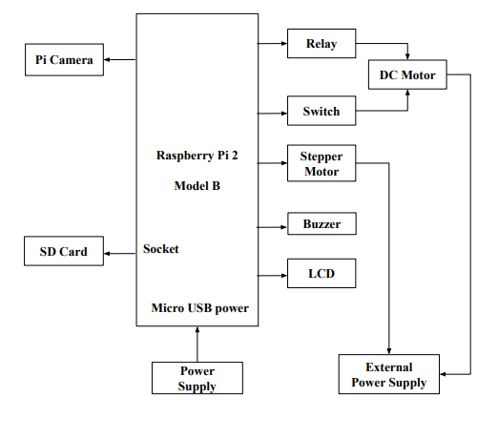

Figure 2: System Design

The above figure (Figure 2) shows the system design of our system. Raspberry Pi 2 Model B is connected to various other components.

1. DC Motor

A Direct Current  motor is one which converts direct current, electrical energy into mechanical energy which has a class of rotary electrical machines. It mainly consists of a stator, an armature, a rotor and a commutator with brushes. Stator is the stationary body of the motor and the inner part that rotates is called a rotor. The speed of rotation of any DC motor varies from few revolutions per minute to thousands of revolutions per minute.

1. METHODOLOGY

The proposed method mainly uses the raspberry pi 2 board which is the main controller of the system. The new version of raspbian buster has been used on the board. The Figure 3 shows the flow diagram of methodology.  At the beginning we need to install the operating system of the raspberry pi to the SD card. Once the operating system is installed we need to connect the components to the hardware and power supply should be switched on. Login through the raspberry pi board and check the network settings. Once the camera is enabled the image has to be captured. The captured image then has to be classified as a positive or negative image  using Haar classifier so we need to run the python code.

OpenCV 4.2:

Open source computer version is one of the open source and machine learning software library. It consists of more than 25,000 algorithms, extensive documentation for real time computers. To detect and recognize faces, identify objects, track camera movements, find similar images from an image database etc these algorithms can be used. It works on  various operating systems such as Windows, Linux, Mac OSX, Android and iOS.

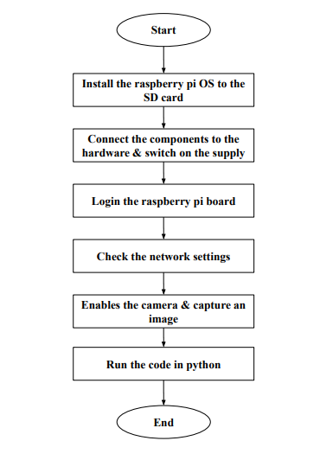

Figure 3: Flow Chart of Methodology

This paper proposes the detection of helmets using a haar cascade classifier, OpenCV and raspberry pi.

The working of the methodology is shown in the form of flowchart in Figure 4. In the bike system  two step key is used.In the first step the bike rider will insert the key and the power is supplied to the raspberry pi.In the second step it will allow the rider to start the bike.when the bike rider will insert the key,power is supplied to the pi camera and the image will be captured by the camera. Then the check has to be made whether the bike rider is wearing the helmet or not. If so then if the bike is in off state allow the rider for the second step of the key and start the bike otherwise capture the image. If the bike rider is not wearing a helmet and the bike is on warning message “No Helmet” has to be displayed on the LCD display and alert the rider with beeping sound for 20 seconds. After 20 seconds if the rider has still not worn the helmet, stop the bike and the key should move to the first step. If the rider has worn the helmet then the image will be captured again.

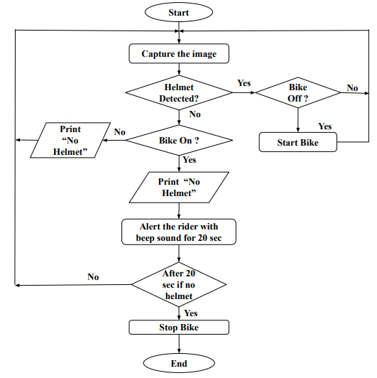

Figure 4: Proposed System Algorithm

1. RESULT

The classifier is trained with positive and negative images, the ratio of positive to negative images where approximately equal to 1:2, after the training procedure is completed an XML file is created which is given as an input file to the python code. Later testing is done. Below shows the result of the testing procedure where both with helmet image and without helmet image is given to test.

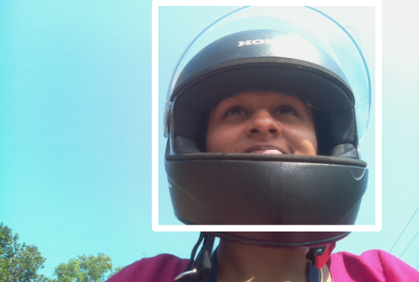

Figure 5: Helmet Detected

The above figure (Figure 5) shows the result of capture from raspberry pi using pi camera. When this image is given as input to the python code to detect the helmet, it is classified as positive and returns the region where the helmet is detected within a rectangular box.

Next image provided as input is shown above, where there is no presence of a helmet and thus the python code classifies it as a negative image and does not create a rectangular box.



Figure 6: Helmet not Detected

VI. CONCLUSION

Haar features along with cascade algorithm (popularly known as haar cascade classifier) is widely used in Object Detection concept. In our project we have used this concept to detect the presence of  helmet. A very big set of positive and negative examples has to be provided during the training session so as to get the required output correctly. The training is time consuming, but after training the classification of the image with/ without an object is fast.

The experimental results show how the testing procedure will provide the output. Even though sensors can be used to detect the presence of a helmet, usage of ML and Image Processing concepts will reduce the sensors used and will also overcome the necessity to wear a specific kind of helmet.

VII. FUTURE ENHANCEMENT

In this project we have only concentrated on detection of helmet in day, this project can further be extended to detect the helmet at night by using night vision cameras.

REFERENCS

1. Gonzalez, Rafael (2018). *Digital image processing*. New York, NY: Pearson. ISBN 978-0-13-335672-4.
2. P. Viola and M. Jones, "Rapid object detection using a boosted cascade of simple features," *Proceedings of the 2001 IEEE Computer Society Conference on Computer Vision and Pattern Recognition. CVPR 2001*, Kauai, HI, USA, 2001.
3. R. Silva, K. Aires, T. Santos, K. Abdala, R. Veras and A. Soares, "Automatic detection of motorcyclists without helmet," *2013 XXXIX Latin American Computing Conference(CLEI), Naiguata, 2013.*
4. R. Waranusast, N. Bundon, V. Timtong, C. Tangnoi and P. Pattanathburt, "Machine vision techniques for   motorcycle   safety helmet   detection," *2013 28th International Conference on Image and Vision Computing NewZealand(IVCNZ2013), Wellington, 2013.*
5. Lokesh Allamki, Manjunath Panchakshari, Ashish Sateesha, K S Pratheek ”Helmet Detection using Machine   Learning and   Automatic License   Plate Recognition”   *International   Research Journal   of Engineering and Technology (IRJET), Volume: 06 Issue: 12 Dec 2019.*
6. A. Arunmozhi and J. Park, "Comparison of HOG, LBP and Haar-Like Features for On-Road Vehicle Detection” *2018 IEEE International Conference on Electro/Information Technology(EIT), Rochester, MI, 2018*
7. Romuere Silva , Kelson Aires and Rodrigo Veras “Helmet Detection on Motorcyclists Using Image Descriptors and Classiﬁers” *2014 27th SIBGRAPI Conference On Graphics, Pattern sand Images, Rio de Janeiro, 2014.*
8. Priya Samyuktha.M, Siva Bharathi. K, Sivagami. A, 2016, “Haar Cascade Algorithm for the Visually Impaired to Detect and Recognize Objects”, *International Journal Of Engineering Research & Technology (IJERT) Volume 05, Issue 04 (April 2016).*
9. H. A. Patel and R. D. Rajput, "Smart Surveillance System Using Histogram of Oriented Gradients (HOG) Algorithm and Haar Cascade Algorithm,” *2018 Fourth  International Conference on Computing Communication Control and Automation(ICCUBEA), Pune, India, 2018.*
10. K.S.Shilpashree, Lokesh.H, Hadimani Shivkumar “Implementation of Image Processing on Raspberry Pi”, *International Journal Of Advanced Research In Computer And Communication Engineering, vol4, issue 5, may 2015*
11. S.Adhav, R.Manthira moorthi, G.Prethija “Image processing based intruder Detection using Raspberry PI” *International Journal of Advanced Networking & Applications (IJANA), May 2015.*
12. K. Dahiya, D. Singh, C. K. Mohan, "Automatic detection of bike-riders without helmet using surveillance  videos in real-time," *2016  International  Joint Conference  on Neural Networks  (IJCNN), Vancouver, BC, 2016.*
13. Sustek M, Marcanik, M, Tomasek , & Urednicek , Z.  (2017). “DC motors and servo-motors controlled by Raspberry Pi 2 B”. *MATEC Web of Conferences,125,02025.*
14. Shabrin, Bhagyashree, Jagadish Nikharge, Maithri M Poojary, T Pooja, Adana B “Smart helmet-   Intelligent Safety For Motorcyclist Using Raspberry Pi And OpenCv” *International Research Journal of Engineering and Technology (IRJET) Volume: 03 Issue: 03  Mar-2016*